Java assignment

1. Write a program called **PrintDayInWord** which prints “Sunday”, “Monday”, ... “Saturday” if the int variable "day" is 0, 1, ..., 6, respectively. Otherwise, it shall print “Not a valid day”. Use (a) a "nested-if" statement; (b) a "switch-case" statement.

**public** **class** PrintDayInWord {

**int** day;

String result;

**public** String if_else_method(**int** d){

**if** (d==0)

**return** "Sunday";

**else** **if** (d==1)

**return** "Monday";

**else** **if** (d==2)

**return** "Tuesday";

**else** **if** (d==3)

**return** "Wednesday";

**else** **if** (d==4)

**return** "Thursday";

**else** **if** (d==5)

**return** "Friday";

**else** **if** (d==6)

**return** "Saturday";

**else**

**return** "Not a valid day";

}

**public** String switch_method(**int** d){

**switch**(d){

**case** 0:

**return** "Sunday";

**case** 1:

**return** "Monday";

**case** 2:

**return** "Tuesday";

**case** 3:

**return** "Wednesday";

**case** 4:

**return** "Thursday";

**case** 5:

**return** "Friday";

**case** 6:

**return** "Saturday";

**default**:

**return** "Not a valid day";

}

}

**public** **static** **void** main(String[] args) {

// **TODO** Auto-generated method stub

PrintDayInWord o = **new** PrintDayInWord();

System.***out***.println (o.result=o.if_else_method(o.day));

System.***out***.println (o.result=o.switch_method(o.day));

}

}

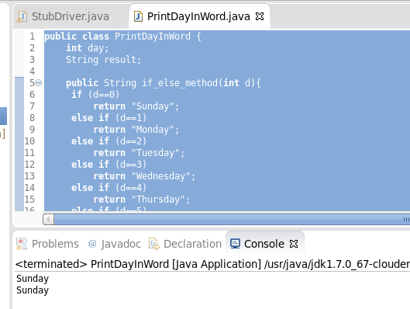

2. Write a program called **SumAndAverage** to produce the sum of 1, 2, 3, ..., to 100. Also compute and display the average. The output shall look like: The sum is 5050 and The average is 50.5

a. Modify the program to use a "while-do" loop instead of "for" loop.

b. Modify the program to use a "do-while" loop.

c. What is the difference between "for" and "while-do" loops? What is the difference between "while-do" and "do-while" loops?

d. Modify the program to sum from 111 to 8899, and compute the average. Introduce an int variable called count to count the numbers in the specified range.

e. Modify the program to sum only the *odd* numbers from 1 to 100, and compute the average. (HINTS: n is an odd number if n % 2 is not 0.)

f. Modify the program to sum those numbers from 1 to 100 that is divisible by 7, and compute the average.

g. Modify the program to find the "sum of the squares" of all the numbers from 1 to 100, i.e. 1*1 + 2*2 + 3*3 + ... + 100*100.

**public** **class** SumAndAverage {

**public** **void** calculate(**int** a,**int** b){

**int** sum=0;

**int** count=0;

**float** avg=0.0f;

**for** (**int** i=a;i<=b;i++){

sum+=i;

count++;

}

avg=(**float**)sum/count;

System.***out***.println("sum of terms= " +sum);

System.***out***.println("average of terms= " +avg);

}

**public** **static** **void** main(String[] args) {

// **TODO** Auto-generated method stub

SumAndAverage sna = **new** SumAndAverage();

sna.calculate(1, 100);

}

}

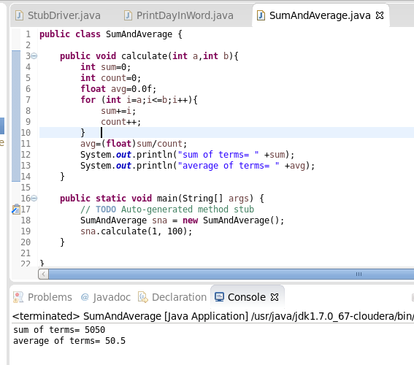

Ans 2(a):

**public** **class** SumAndAverage {

**public** **void** calculate(**int** a,**int** b){

**int** sum=0, i=1;

**int** count=0;

**float** avg=0.0f;

**while**( i<=b){

sum+=i;

count++;

i++;

}

avg=(**float**)sum/count;

System.***out***.println("sum of terms= " +sum);

System.***out***.println("average of terms= " +avg);

}

**public** **static** **void** main(String[] args) {

// **TODO** Auto-generated method stub

SumAndAverage sna = **new** SumAndAverage();

sna.calculate(1, 100);

}

}

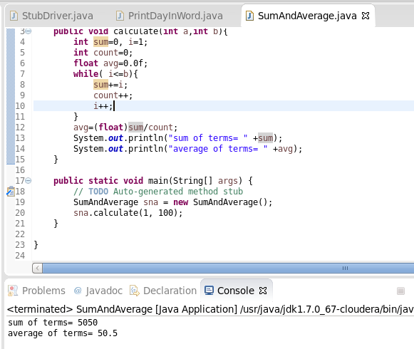

Ans 2(b):

**public** **class** SumAndAverage {

**public** **void** calculate(**int** a,**int** b){

**int** sum=0, i=1;

**int** count=1;

**float** avg=0.0f;

**do**{

sum+=a;

a++;

}**while**(a<=b);

avg=(**float**)sum/b;

System.***out***.println("sum of terms= " +sum);

System.***out***.println("average of terms= " +avg);

}

**public** **static** **void** main(String[] args) {

// **TODO** Auto-generated method stub

SumAndAverage sna = **new** SumAndAverage();

sna.calculate(1, 100);

}

}

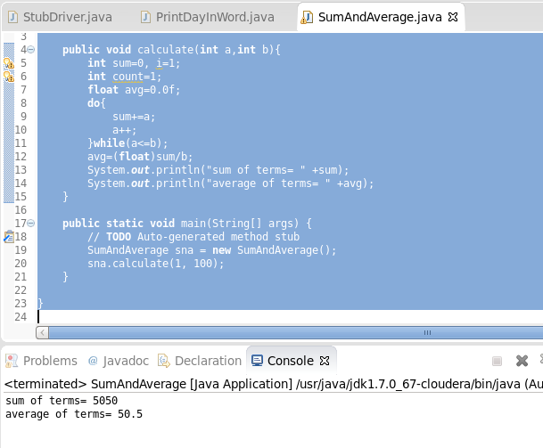

2(c)

**For and while-do:** In for loop we put initialization and condition in same line which may or may not require some condition. while in while-do loop condition is necessary to be put.

**while-do and do-while:** In do-while loop, body gets executed once even if condition fails while in while-do loop it first checks the condition then only executes the body of loop.

Ans 2(d):

**public** **class** SumAndAverage {

**public** **void** calculate(**int** a,**int** b){

**int** sum=0, i;

**int** count=0;

**float** avg=0.0f;

i=a;

**while**( i<=b){

sum+=i;

count++;

i++;

}

avg=(**float**)sum/count;

System.***out***.println("sum of terms= " +sum);

System.***out***.println("average of terms= " +avg);

System.***out***.println("Total count= " +count);

}

**public** **static** **void** main(String[] args) {

// **TODO** Auto-generated method stub

SumAndAverage sna = **new** SumAndAverage();

sna.calculate(111, 8899);

}

}

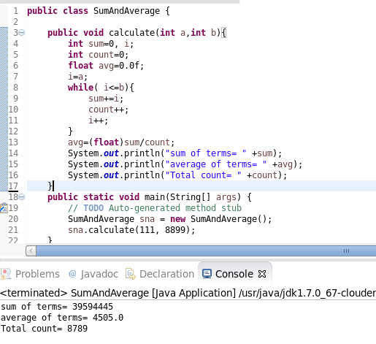

Ans 2(e):

**public** **class** SumAndAverage {

**public** **void** calculate(**int** a,**int** b){

**int** sum=0, i;

**int** count=0;

**float** avg=0.0f;

i=a;

**while**( i<=b){

**if** (i%2!=0){

sum+=i;

count++;

}

i++;

}

avg=(**float**)sum/count;

System.***out***.println("sum of terms= " +sum);

System.***out***.println("average of terms= " +avg);

System.***out***.println("Total count= " +count);

}

**public** **static** **void** main(String[] args) {

// **TODO** Auto-generated method stub

SumAndAverage sna = **new** SumAndAverage();

sna.calculate(1, 100);

}

}

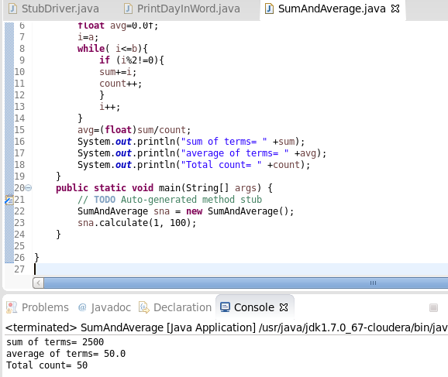

Ans 2(f):

**public** **class** SumAndAverage {

**public** **void** calculate(**int** a,**int** b){

**int** sum=0, i;

**int** count=0;

**float** avg=0.0f;

i=a;

**while**( i<=b){

**if** (i%7==0){

sum+=i;

count++;

}

i++;

}

avg=(**float**)sum/count;

System.***out***.println("sum of terms= " +sum);

System.***out***.println("average of terms= " +avg);

System.***out***.println("Total count= " +count);

}

**public** **static** **void** main(String[] args) {

// **TODO** Auto-generated method stub

SumAndAverage sna = **new** SumAndAverage();

sna.calculate(1, 100);

}

}

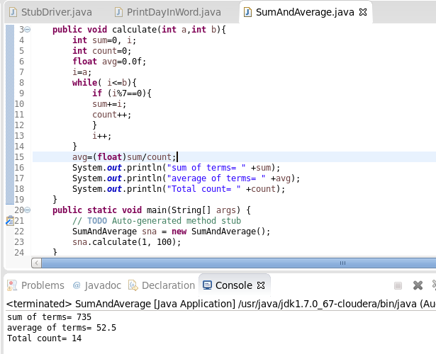

Ans 2(g):

**public** **class** SumAndAverage {

**public** **void** calculate(**int** a,**int** b){

**int** sum=0, i;

**int** count=0;

**float** avg=0.0f;

i=a;

**while**( i<=b){

sum+=(i*i);

count++;

i++;

}

avg=(**float**)sum/count;

System.***out***.println("sum of terms= " +sum);

System.***out***.println("average of terms= " +avg);

System.***out***.println("Total count= " +count);

}

**public** **static** **void** main(String[] args) {

// **TODO** Auto-generated method stub

SumAndAverage sna = **new** SumAndAverage();

sna.calculate(1, 100);

}

}

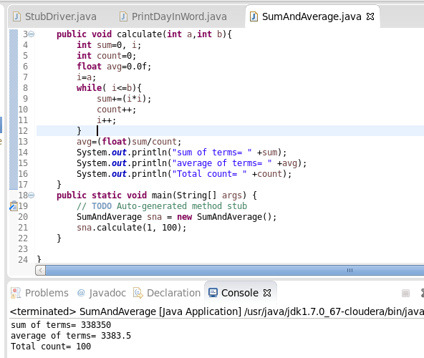

3. Write a program called **FileScanner** to read an int, a double, and a String form a text file called "in.txt", and produce the following output:

The integer read is 12

The floating point number read is 33.44

The String read is "Alabs"

Hi! Peter, the sum of 12 and 33.44 is 45.44

You need to create a text file called "in.txt" (in Eclipse, right-click on the "project" ⇒ "New" ⇒ "File") with the following contents:

12

33.44

Peter

**import** java.io.BufferedReader;

**import** java.io.File;

**import** java.io.FileReader;

**import** java.io.IOException;

**public** **class** FileScanner {

**public** **static** **void** main(String[] args) **throws** IOException {

**int** linenumber;

String stringValue="",intValue="",doubleValue="";

**double** dblVal1=0,dblVal2=0;

File fp=**new** File("/home/cloudera/workspace/Assignment/in.txt");

BufferedReader br = **new** BufferedReader(**new** FileReader(fp));

**for**(linenumber=1;linenumber<=3;linenumber++)

{

**if**(linenumber==1)

{

intValue=br.readLine();

System.***out***.println("The integer read is "+ intValue);

dblVal1 = Double.*parseDouble*(intValue);

}

**if**(linenumber==2)

{

doubleValue=br.readLine();

dblVal2 = Double.*parseDouble*(doubleValue);

System.***out***.println("The floating point number read is "+ doubleValue);

}

**if**(linenumber==3)

{

stringValue=br.readLine();

System.***out***.println("The String read is "+ stringValue);

}

}

**double** sum =dblVal1+dblVal2;

System.***out***.println("Hi "+ stringValue + " the sum of "+intValue +" and "+doubleValue+" is "+ sum);

}

}

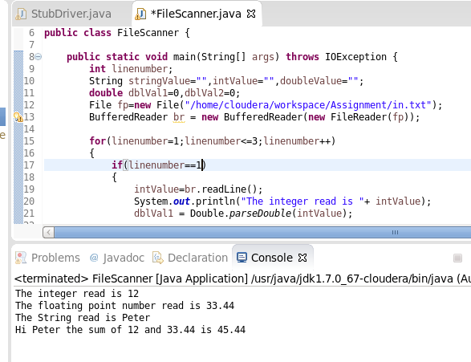

4. Write a program called **CheckVowelsDigits**, which prompts the user for a String, counts the number of vowels (a, e, i, o, u, A, E, I, O, U) and digits (0-9) contained in the string, and prints the counts and the percentages (with 2 decimal digits).

For example,

Enter a String: testing12345

Number of vowels: 2 (16.67%)

Number of digits: 5 (41.67%)

**import** java.util.Scanner;

**public** **class** CheckVowelsDigits {

**public** **static** **void** main(String[] args) {

// **TODO** Auto-generated method stub

String sample;

**int** i, v_count=0, d_count=0;

Scanner sc= **new** Scanner(System.***in***);

System.***out***.println("Enter Sample String: ");

sample= sc.next();

**for**(i=0;i<sample.length();i++){

**if** (sample.charAt(i)=='a' || sample.charAt(i)=='A'|| sample.charAt(i)=='e'|| sample.charAt(i)=='E' || sample.charAt(i)=='i'|| sample.charAt(i)=='I' ||

sample.charAt(i)=='o'|| sample.charAt(i)=='O' || sample.charAt(i)=='u'|| sample.charAt(i)=='U')

v_count++;

**else** **if** (sample.charAt(i)=='0' || sample.charAt(i)=='1'|| sample.charAt(i)=='2'|| sample.charAt(i)=='3' || sample.charAt(i)=='4'|| sample.charAt(i)=='5' ||

sample.charAt(i)=='6'|| sample.charAt(i)=='7' || sample.charAt(i)=='8'|| sample.charAt(i)=='9')

d_count++;

}

System.***out***.println("No of Vowels = "+ v_count+" ("+ (**float**)(v_count*100/i) + ")" );

System.***out***.println("No of Digits = "+ d_count+" ("+ (**float**)(d_count*100/i) + ")" );

}

}

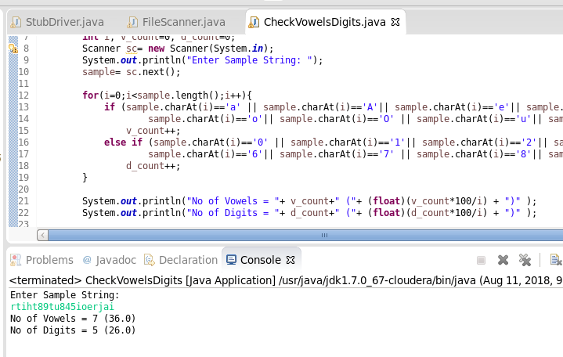

5. Write a program called **GradesStatistics**, which reads in *n* grades (of int between 0 and 100, inclusive) and displays the *average*, *minimum*, *maximum*, *median* and *standard deviation*. Display the floating-point values upto 2 decimal places. Your output shall look like:

**(Incomplete Question)**